**COMSATS University Islamabad (CUI)**

**Department of Computer Science**

**CSC339- Data Communication and Computer Networks**

**BSE-5B FALL 2021**

**Quiz-3**

**____________________________________________________**

**Question 1 Marks 2**

Please compare and contrast the advertisements used by OSPF and RIP.

**Ans:**

* With OSPF, a router periodically broadcasts routing information to all other routers in the AS, not just to its neighbouring routers. This routing information sent by a router has one entry for each of the router’s neighbour’s; the entry gives the distance from the router to the neighbour.
* A RIP advertisement sent by a router contains information about all the networks in the AS, although this information is only sent to its neighbouring routers.

**Question 2 Marks 4**

Consider the scenario below in which three hosts, with private IP addresses 10.0.1.13, 10.0.1.17, 10.0.1.19 are in a local network behind a NAT'd router that sits between these three hosts and the larger Internet. IP datagrams being sent from, or destined to, these three hosts must pass through this NAT router. The router’s interface on the LAN side has IP address 10.0.1.25, while the router’s address on the Internet side has IP address 135.122.200.210

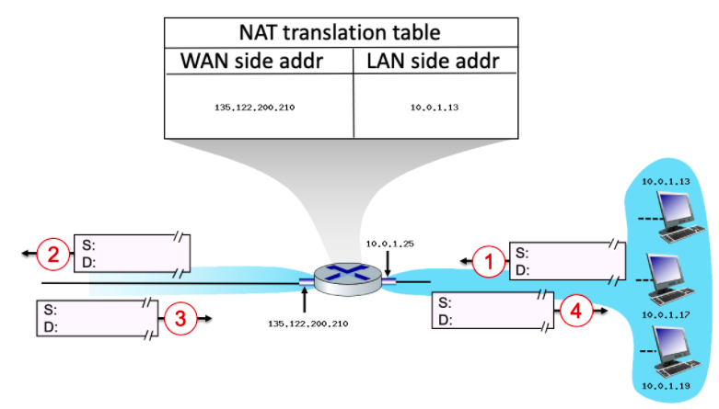

Suppose that the host with IP address 10.0.1.13 sends an IP datagram destined to host 128.119.163.189. The source port is 3431, and the destination port is 80.

1. Consider the datagram at step 1, after it has been sent by the host but before it has reached the router. What is the source IP address for this datagram?
2. At step 1, what is the destination IP address?
3. Now consider the datagram at step 2, after it has been transmitted by the router. What is the source IP address for this datagram?
4. At step 2, what is the destination IP address for this datagram?
5. Will the source port have changed? Yes or No.

**Ans:**

1. The source address will be the local host's IP, which is 10.0.1.13  
2. The destination address will be the remote machine's IP, which is 128.119.163.189  
3. The source address will be the router's public IP, which is 135.122.200.210  
4. The destination address will be the remote machine's IP, which is 128.119.163.189  
5. Yes, the NAT will change the source port.

**Question 3 Marks 4**

Consider the network shown in Fig.2 below. With the indicated link costs, use **Dijkstra’s shortest-path** algorithm to calculate the shortest path from **u** to **Z** all network nodes. Please write down intermediate steps in obtaining the solution.

**Ans:**

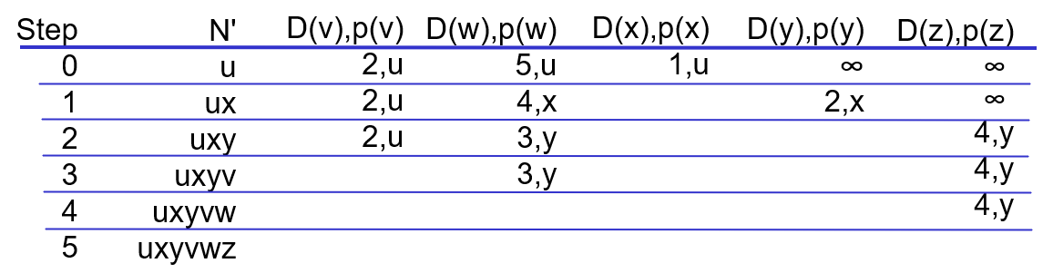

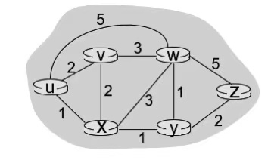

**Fig.2**